Exercise No: 5

Date: 14-10-2020

Aim:

To Write a Python function to print missing characters to make string pangram.

Program:

input_str = input()

input_str = set(input_str.strip())

input_str.remove(chr(32))

str = "abcdefghijklmnopqrstuvwxyz"

str = set(str)

str = str.difference(input_str)

str = list(str)

str.sort()

print("".join(str))

Link:

[http://103.53.53.18/mod/vpl/forms/edit.php?id=235&userid=1706#](http://103.53.53.18/mod/vpl/forms/edit.php?id=235&userid=1706)

Output:

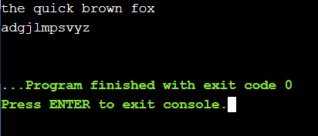

Result:

Thus the output for the Python function to print missing characters to make string pangram was verified.